HTS HTS INC HTC HTV CVS CVS INC CROSS EYE STRABISMUS LAZY EYE AMBLYOPIA STRESS INDUCED VISION PROBLEMS NEAR WORK EYE STRAIN EYE STRAIN COMPUTER VISION REHAB REHABILITATION

SPORTS VISION 20/20 SNELLEN CLEAR VISION

CONVERGENCE CONVERGENCE INSUFFICIENCY DEPTH PERCEPTION DEVELOPMENTAL OPTOMETRIST OPHTHALMOLOGY OPTOMETRIC OPTOMETRY OPHTHALMOLOGIST DIVERGENCE FUNCTIONAL VISION HYPEROPIA FARSIGHTEDNESS MYOPIA NEARSIGHTEDNESS M.D. MD O.D. OD FCOVD OPTICIAN

DOCTORS OF OPTOMETRY DOCTOR PRIMARY HEALTH CARE PROFESSIONAL STEREOPSIS 3D VISION BINOCULAR MONOCULAR DIPLOPIA ESOTROPIA EXOTROPIA EYE TEAMING EYE TRACKING FOCUSING HAND EYE COORDINATION INTERMITTENT LATERALITY MONOCULAR VISION THERAPY AUDITORY INTEGRATION DISTRACTORS ACUITY ASTIGMATISM FIXATION FUSION

RESEARCH LINKS STUDIES DONE

<https://visiontherapysolutions.net/research/>

[www.visiontherapysolutions.net/research/](http://www.visiontherapysolutions.net/research/)

[www.visiontherapysolutions.net](http://www.visiontherapysolutions.net)

[www.homevisiontherapy.com](http://www.homevisiontherapy.com)

[www.htstechsupport.com](http://www.htstechsupport.com)

[www.hts.vision](http://www.hts.vision)

[E:\HTS logo with eye.tif](http://www.hts.vision)[E:\HTS logo with eye.tif](http://www.visiontherapysolutions.net/hts-inet/)[E:\HTS logo with eye.tif](http://www.htstechsupport.com)

[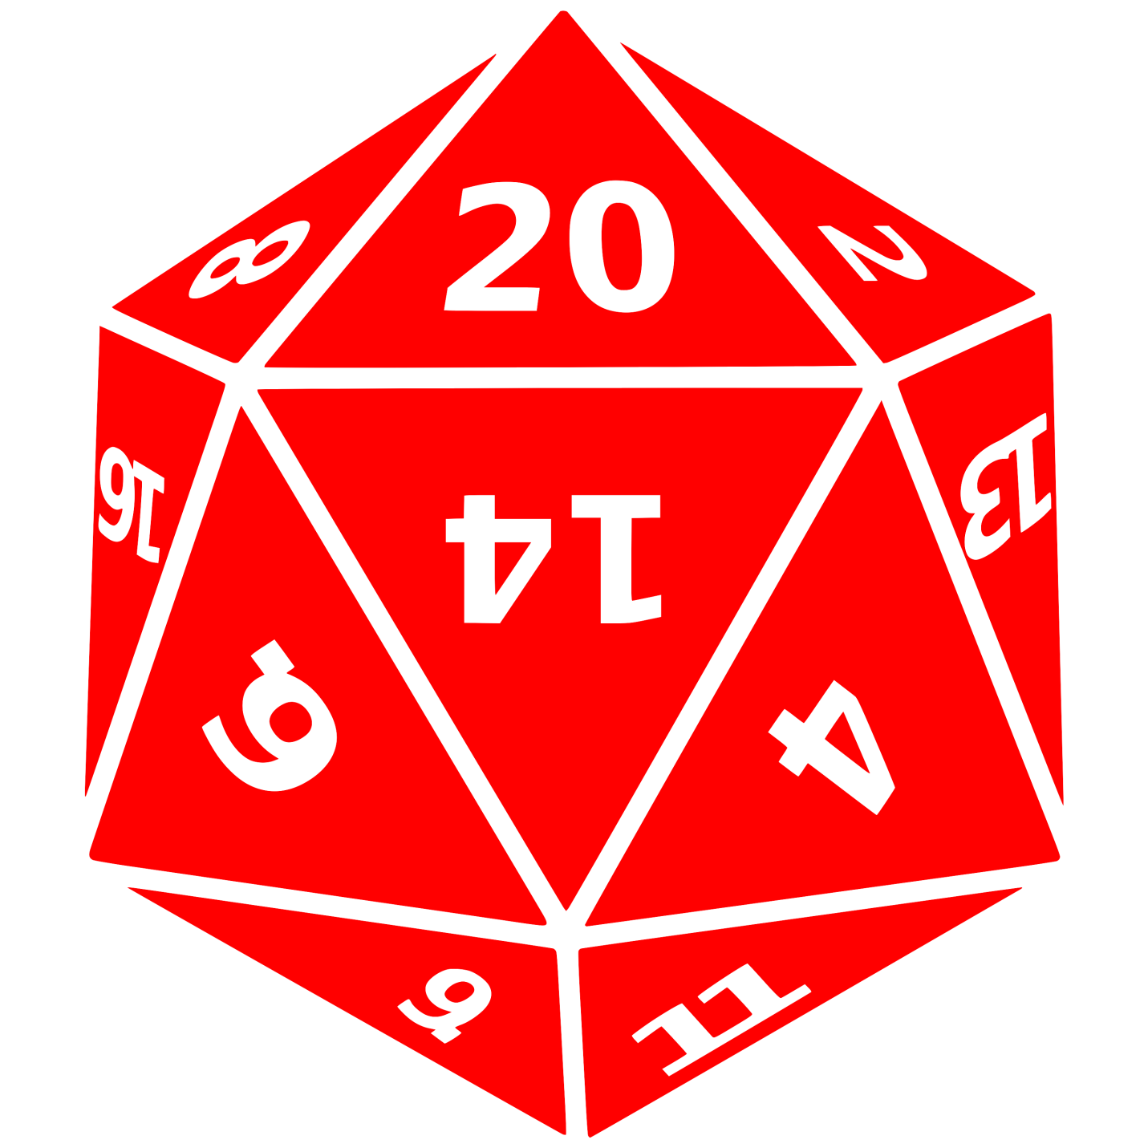](http://www.hts.vision)H:\FlatFusion\Car\CarIcon.png